CONFIDENTIAL  CS/MOCK OCT 2026/CSC662

UNIVERSITI TEKNOLOGI MARA FINAL EXAMINATION

COURSE :
COURSE CODE :
EXAMINATION :
TIME :
COMPUTER SECURITY
CSC662
OCTOBER 2026 (MOCK)
3 HOURS

INSTRUCTIONS TO CANDIDATES

- This question paper consists of two (2) parts: PART A (10 Questions)
PART B (2 Questions)

- Answer ALL questions in the Answer Booklet. Start each answer on a new page.

- Do not bring any material into the examination room unless permission is given by the invigilator.
- Please check to make sure that this examination pack consists of: i) the Question Paper
ii) an Answer Booklet - provided by the Faculty

- Answer ALL questions in English.

DO NOT TURN THIS PAGE UNTIL YOU ARE TOLD TO DO SO

This examination paper consists of 6 printed pages

PART A (80 MARKS)

QUESTION 1
- State TWO (2) differences between morals and laws as forms of conduct guidance for computing professionals.
(2 marks)
- Discuss how a professional code of ethics and conduct guides the behaviour of a computing professional, referring to the ACM code and its professional conduct expectations. Support your discussion with six distinct requirements.
(6 marks)
QUESTION 2
- Explain how a substitution cipher conceals the original message and what role the substitution rule plays in that process.
(2 marks)
- Decrypt the following ciphertext using the Vigenere cipher with the key CIPHER. Use the standard 26 x 26 Vigenere tableau, writing the key over the message and repeating it as necessary.
UMRBVVNWVPREQE
(6 marks)
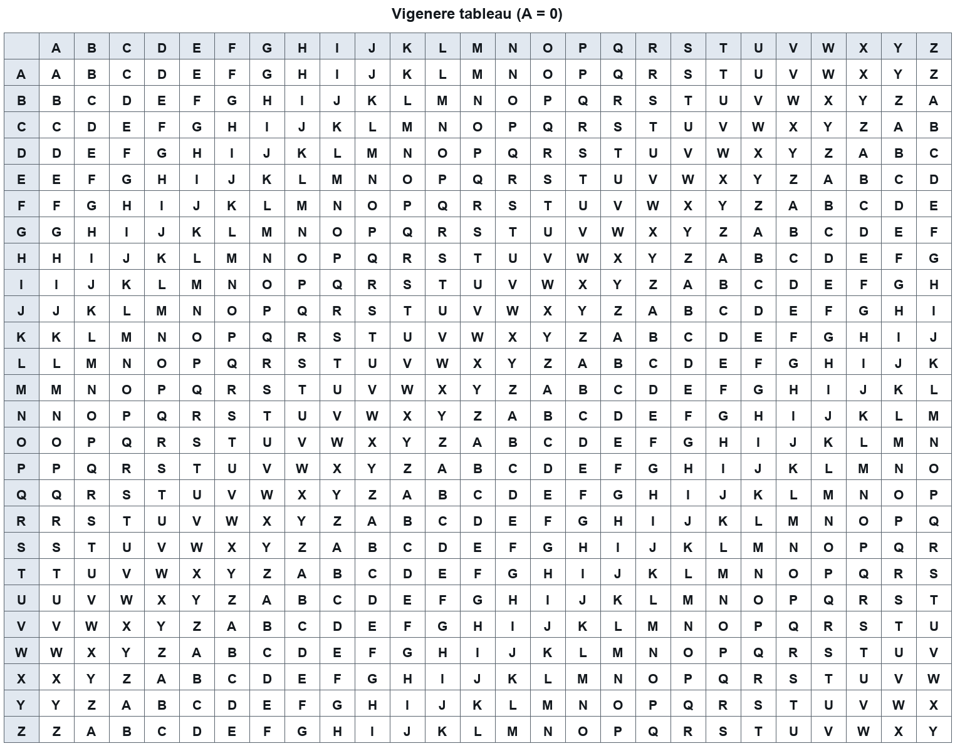

QUESTION 3
- State the two stages of the biometric authentication process and, for each stage, name the activities it involves.
(2 marks)
- State six facts about biometric mechanisms and technologies as covered in the course, covering the definition of a biometric, the two application sectors, the behavioural examples, the physiological examples, the fingerprint process, and the iris scanning advantages.
(6 marks)
QUESTION 4
- List two formal security models named in the lecture and, for each, state the specific security concern it is designed to address.
(2 marks)
- [COMPUTED PLACEHOLDER - acm, 6 marks]
(6 marks)
QUESTION 5
- State TWO (2) characteristics of a Trojan horse as a type of malware.
(2 marks)
- Explain how malware such as viruses and worms propagate and conceal themselves, giving six distinct techniques or behaviours drawn from the history and mechanics of malware.
(6 marks)
QUESTION 6
- Explain how a network-based intrusion detection system (NIDS) should be architected, with particular reference to where its sensors are placed.
(2 marks)
- Refer to your answer in (a). Explain how preventive network security mechanisms such as firewalls, proxy servers, network segmentation and remote access VPNs reduce the workload and exposure of the detection system you described, giving six distinct points.
(6 marks)
QUESTION 7
- Explain how a chain of trust is established in the Trusted Computing architecture, with reference to the TPM and the measurement of each stage.
(2 marks)
- Describe six (6) components and characteristics of the Next Generation Secure Computing Base (NGSCB), focusing on the Nexus and the Nexus Computing Agent (NCA).
(6 marks)
QUESTION 8
- List two classes of threats and, for each, state the security objective whose violation represents the harm caused to the system.
(2 marks)
- State six (6) facts about the Samy worm as a case study of a cross-site scripting (XSS) attack, covering how the malicious script was injected, how it spread to other users, and the scale of the infection.
(6 marks)
QUESTION 9
- Explain two ways in which an intrusion detection system contributes to detecting and defending against attacks on a computer system.
(2 marks)
- Describe six (6) distinct software threat classes or attack techniques that can compromise a computer system, and for each, state the security objective that the attack violates.
(6 marks)
QUESTION 10
- Explain how a buffer overflow arises in a program such as one using strcpy(), and state why this class of flaw is so widely exploited by attackers.
(2 marks)
- Explain six Windows security mechanisms and features that support user account management, object access control and system protection, and discuss why the complexity of these mechanisms can itself become a security weakness.
(6 marks)
PART B (20 MARKS)

QUESTION 1
- Discuss the access control structures used to implement access policies, covering the access control matrix, access control lists and capabilities, and the requirements these structures must satisfy.
(5 marks)
- Explain the goals that access control is intended to achieve and the role of the reference monitor in making authorization decisions, including how a reference monitor is realised in the Windows security architecture.
(5 marks)
QUESTION 2
A small company runs a shared Linux server where staff log in with user names and passwords. The administrator is reviewing how password files are protected and how accounts are handled after repeated failed logins, and wants to tighten the password controls in place.
- Explain five password security controls that an administrator can apply to protect user accounts and password files on a multi-user system.
(5 marks)
- The administrator in the scenario wants to reduce the burden of password handling for staff on the shared server. State five points about single sign-on, Kerberos and smart cards as authentication mechanisms that the administrator could rely on.
(5 marks)
END OF QUESTION PAPER

