CONFIDENTIAL  CS/MOCK OCT 2026/CSC662

UNIVERSITI TEKNOLOGI MARA FINAL EXAMINATION

COURSE :
COURSE CODE :
EXAMINATION :
TIME :
COMPUTER SECURITY
CSC662
OCTOBER 2026 (MOCK)
3 HOURS

INSTRUCTIONS TO CANDIDATES

- This question paper consists of two (2) parts: PART A (10 Questions)
PART B (2 Questions)

- Answer ALL questions in the Answer Booklet. Start each answer on a new page.

- Do not bring any material into the examination room unless permission is given by the invigilator.
- Please check to make sure that this examination pack consists of: i) the Question Paper
ii) an Answer Booklet - provided by the Faculty

- Answer ALL questions in English.

DO NOT TURN THIS PAGE UNTIL YOU ARE TOLD TO DO SO

This examination paper consists of 6 printed pages

PART A (80 MARKS)

QUESTION 1
- List TWO (2) typical locations where IDS sensors are placed in a network-based IDS architecture.
(2 marks)
- Explain three preventive network security mechanisms that an organization can deploy to protect its network, and for each mechanism describe how it controls or secures network traffic.
(6 marks)
QUESTION 2
- Explain how a substitution cipher works and state what serves as its key.
(2 marks)
- Decrypt the following ciphertext using the Vigenere cipher with the key CIPHER. Use the standard 26 x 26 Vigenere tableau, writing the key over the message and repeating it as necessary.
UMRBVVNWVPREQE
(6 marks)
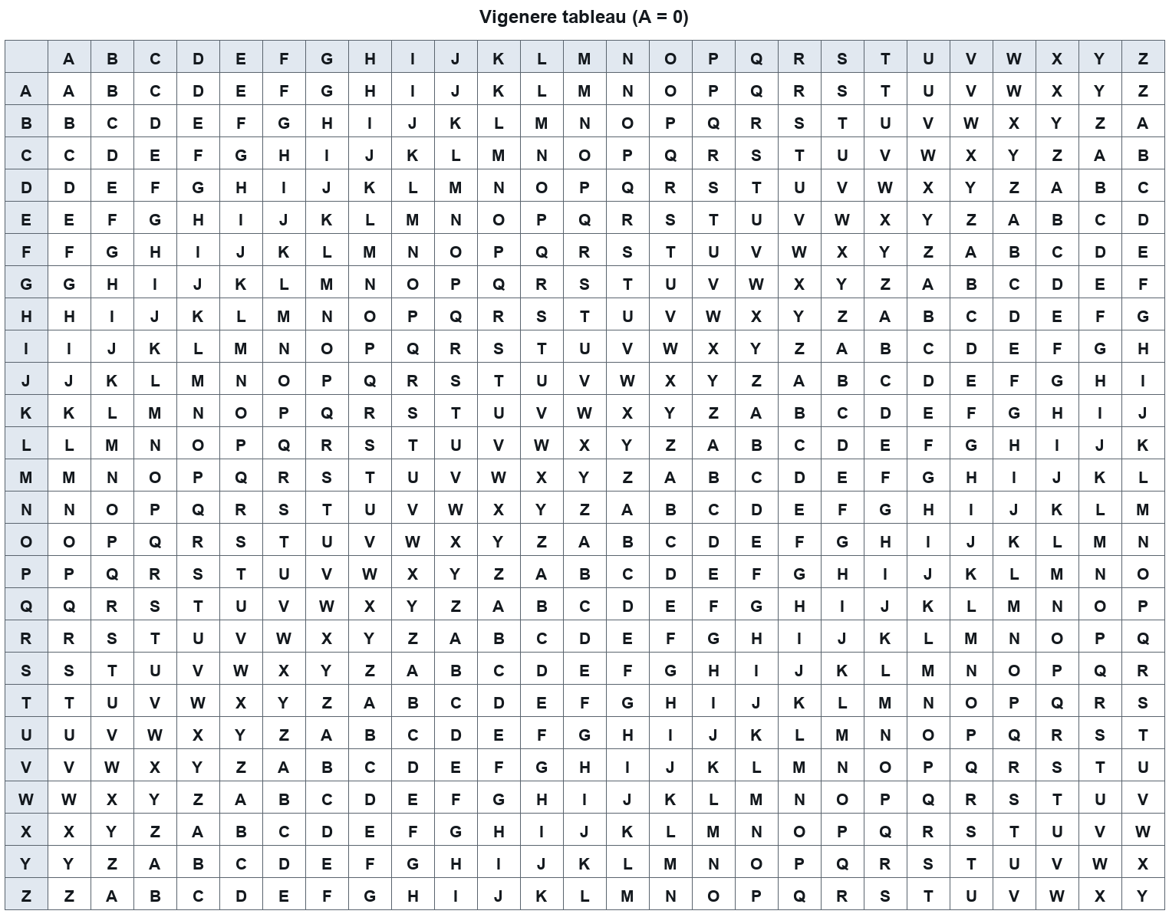

QUESTION 3
- List TWO (2) reasons why software is insecure, with particular reference to buffer overflows.
(2 marks)
- Windows is often described as having rich but complicated security. Explain six aspects of Windows security mechanisms, covering how subjects and credentials are handled, how resources are organised and controlled, and why this complexity can itself become a security problem.
(6 marks)
QUESTION 4
- State TWO (2) characteristics of Trojan horses as a type of malware.
(2 marks)
- Discuss six (6) malware attack techniques and propagation behaviours, explaining how each technique or behaviour enables the malware to spread or to act on an infected system.
(6 marks)
QUESTION 5
- Explain the difference between morals, ethics and laws as sources of guidance for professional conduct in computer security.
(2 marks)
- State six requirements that a professional code of ethics and conduct places on a computing professional, as illustrated by the ACM code and its professional conduct guidance.
(6 marks)
QUESTION 6
- Explain the two stages of the biometric authentication process and state what happens during each stage.
(2 marks)
- Explain the categories of biometric applications and the characteristics of iris and fingerprint technologies, including the practical problems associated with fingerprint systems.
(6 marks)
QUESTION 7
- State TWO (2) formal security models that are classified as information flow models, and state the specific concern that the Chinese Wall model is designed to address.
(2 marks)
- Describe the access control matrix, the access control list and the capability list as access control structures, giving one advantage and one disadvantage of the access control matrix and of the access control list, and stating what a capability list represents.
(6 marks)
QUESTION 8
- Explain two ways in which a documented professional code of ethics shapes the ethical impact of technology practice, as described in the lecture.
(2 marks)
- Refer to your answer in (a). Discuss how professional codes of ethics and the responsibilities of information specialists address privacy and organisational responsibility in computer security practice.
(6 marks)
QUESTION 9
- Explain how a disclosure threat and a usurpation threat each affect the confidentiality, integrity and availability of a system's assets.
(2 marks)
- State six (6) characteristics of the Samy worm and the cross-site scripting (XSS) mechanism it exploited, explaining how each characteristic enabled the worm to spread or to act on an infected profile.
(6 marks)
QUESTION 10
- State TWO (2) detection outcomes that an intrusion detection system may produce when monitoring for attacks, and explain what each outcome indicates about the system's detection accuracy.
(2 marks)
- Discuss six (6) threat classes and countermeasures relevant to computer security, explaining for each how the threat class endangers assets or how the countermeasure addresses it.
(6 marks)
PART B (20 MARKS)

QUESTION 1
- State the role of the TPM in a trusted platform, and explain how a chain of trust is built from the hardware up to the running software. Your answer should identify the roots of trust involved and the mechanism used to record each stage.
(5 marks)
- Discuss the components of the NGSCB architecture, explaining the role of the Nexus and the Nexus Computing Agent and how they work together to protect trusted software from the operating system.
(5 marks)
QUESTION 2
- Explain five password security controls that an administrator can apply to protect a system's password files and accounts, and state one password policy requirement for the root password.
(5 marks)
- A company wants to let staff reach many internal services after a single login, using Kerberos and other single sign-on approaches. Explain the motivation for single sign-on, the design criteria that Kerberos aims to satisfy, and the drawbacks of Kerberos that the company should consider.
(5 marks)
END OF QUESTION PAPER

