CONFIDENTIAL  CS/MOCK OCT 2026/CSC662

UNIVERSITI TEKNOLOGI MARA FINAL EXAMINATION

COURSE :
COURSE CODE :
EXAMINATION :
TIME :
COMPUTER SECURITY
CSC662
OCTOBER 2026 (MOCK)
3 HOURS

INSTRUCTIONS TO CANDIDATES

- This question paper consists of two (2) parts: PART A (10 Questions)
PART B (2 Questions)

- Answer ALL questions in the Answer Booklet. Start each answer on a new page.

- Do not bring any material into the examination room unless permission is given by the invigilator.
- Please check to make sure that this examination pack consists of: i) the Question Paper
ii) an Answer Booklet - provided by the Faculty

- Answer ALL questions in English.

DO NOT TURN THIS PAGE UNTIL YOU ARE TOLD TO DO SO

This examination paper consists of 6 printed pages

PART A (80 MARKS)

QUESTION 1
- Using Caesar Cipher technique, decrypt the following ciphertext with a shift of 7 (replace each letter with the one 7 positions to the left).
KLCPJLYLABYULKHUKDPWLKVUL
(2 marks)
- Explain substitution ciphers as a classical cipher family. In your answer, describe how substitution works, what serves as the key, its relation to Shannon's principle of confusion, and its relevance to modern ciphers.
(6 marks)
QUESTION 2
- Explain how a rail fence transposition cipher works, covering both the encryption and decryption processes.
(2 marks)
- Decrypt the following ciphertext using the Vigenere cipher with the key CIPHER. Use the standard 26 x 26 Vigenere tableau, writing the key over the message and repeating it as necessary.
UMRBVVNWVPREQE
(6 marks)
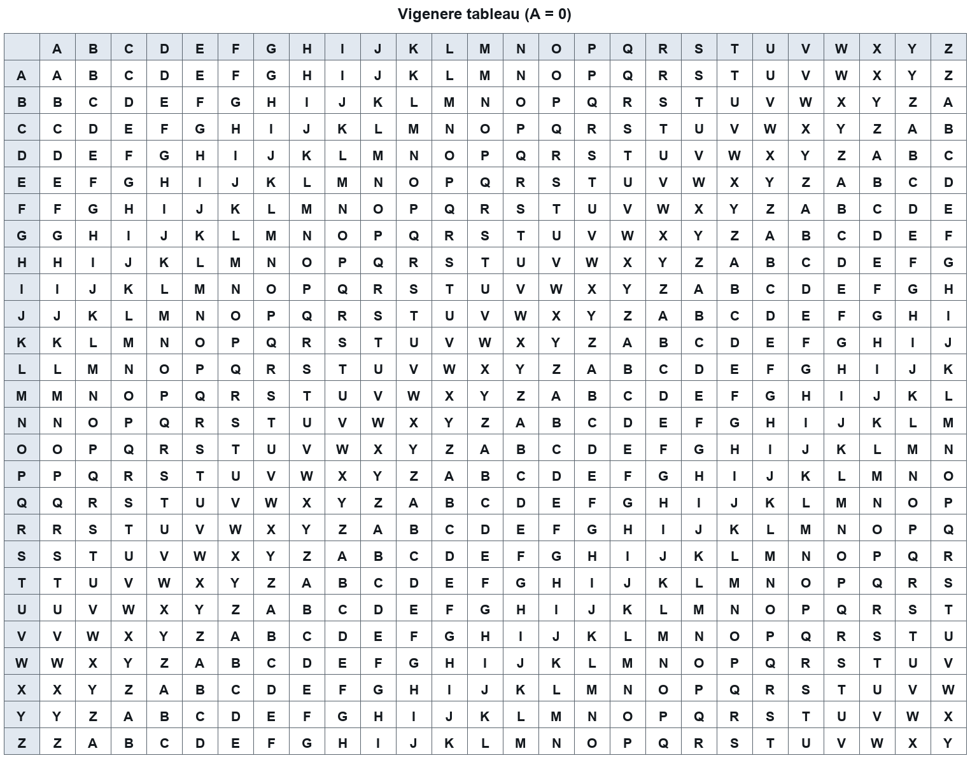

QUESTION 3
- Explain the two stages of the biometric authentication process and state what happens during each stage.
(2 marks)
- Describe six points about biometric mechanisms and technologies, covering what a biometric is, how biometric applications are categorised, and the characteristics and drawbacks of specific biometric technologies.
(6 marks)
QUESTION 4
- List two formal security models named in the lecture and, for each, state the specific security concern it is designed to address.
(2 marks)
- [COMPUTED PLACEHOLDER - acm, 6 marks]
(6 marks)
QUESTION 5
- State TWO (2) facts about how a chain of trust is established using the Trusted Platform Module (TPM) in a trusted computing platform.
(2 marks)
- Explain the roles of the Nexus and the Nexus Computing Agent (NCA) as the two primary system components of the Next Generation Secure Computing Base (NGSCB), and state how the Nexus relates to the TPM and to the operating system.
(6 marks)
QUESTION 6
- List two types of malware and, for each, state one characteristic behaviour that distinguishes it, as described in the software security lecture.
(2 marks)
- Discuss six techniques by which malware attacks and propagates through a system, drawing on the software security lecture's account of malware behaviour and infection mechanisms.
(6 marks)
QUESTION 7
- Explain how the classes of threats described in the introduction to computer security affect confidentiality, integrity and availability.
(2 marks)
- State six facts about the Samy worm and the cross-site scripting (XSS) attack it exploited, covering how the malicious script was injected, how it spread between users, why the browser permitted it, and the outcome of the incident.
(6 marks)
QUESTION 8
- Explain how a buffer overflow arises in a program such as one using strcpy() and how an attacker can exploit it to hijack execution.
(2 marks)
- Describe six Windows security mechanisms and related design considerations that a system administrator must understand when securing a Windows host, covering how subjects are represented, how access to objects is controlled, how resources are organised, and why the complexity of these mechanisms can itself be a risk.
(6 marks)
QUESTION 9
- State TWO (2) differences between morals and laws as described in the lecture on ethics and computer security.
(2 marks)
- Refer to your answer in (a). Explain how a professional code of ethics and conduct guides a computing professional, using the ACM code to illustrate six (6) distinct professional obligations.
(6 marks)
QUESTION 10
- State TWO (2) typical locations where IDS sensors are placed in a network-based IDS architecture.
(2 marks)
- Explain six (6) preventive network security mechanisms that an organization can deploy, describing what each mechanism does to protect the network.
(6 marks)
PART B (20 MARKS)

QUESTION 1
- Explain five password security controls that an organisation can apply to protect user accounts and password files, and state one password policy practice for the root password.
(5 marks)
- A large organisation wants to reduce the number of passwords its staff must remember and manage. Explain five points about single sign-on and Kerberos that the organisation should consider, covering the motivation for single sign-on, the authentication categories involved, Kerberos design criteria, the initial Kerberos exchange, and the limitations of Kerberos.
(5 marks)
QUESTION 2
A security architect is comparing how operating systems and formal models represent access rights. She examines an object-centred list attached to a file, a matrix of subjects against objects, and a capability list held by each subject, and asks how these structures differ in what they make easy to see and easy to revoke.
- State five points about access control structures, covering the three named structures, the requirements they must satisfy, and the advantages and disadvantages of an access control list.
(5 marks)
- Referring to the scenario, discuss the authorization goals that an access control system must serve and explain how a reference monitor supports these goals, including the role of the Chinese Wall model in controlling access.
(5 marks)
END OF QUESTION PAPER

